Probing the Curious Chemistry in Micro- and Nanodroplets using Nanoelectrochemistry
SEMINAR PROGRAMME 2023 DIPARTIMENTO DI CHIMICA “GIACOMO CIAMICIAN”

Venerdi, 09 Giugno, 2023

14:00
Aula I & TEAMS

Dipartimento di Chimica “Giacomo Ciamician”
Via F. Selmi 2
40126 – Bologna
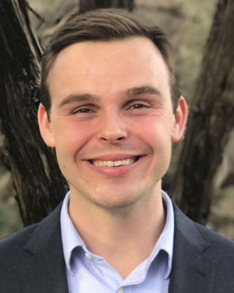
Jeffrey E. Dick
Department of Chemistry and Elmore Family School of Electrical and Computer Engineering
(www.nanoelectrochemistry.com)
Purdue University, West Lafayette, IN 47907

Abstract: Over the last 20 years, groups have shown that chemical reactions proceed differently in confined volumes compared to bulk, continuous phases. This talk will detail our group's efforts in developing new electrochemical measurement tools to study chemistry in tiny volumes. Using stochastic electrochemistry, we show that enzymatic rates can be enhanced by orders of magnitude, and the enhancement scales with the inverse of nanodroplet radius. We also demonstrate direct electrochemical evidence of spontaneously produced hydrogen peroxide in aqueous microdroplets suspended in an organic phase. Using new measurement approaches, we detail electroanalysis in a single dissolving droplet, which allows for unprecedented insight into the physical properties of droplets smaller than the diffraction limit of light. The technique can also be used to enrich concentrations by 10⁶, greatly amplifying analytical figures of merit.

